MessageChatMemoryAdvisor + QuestionAnswer Advisor interaction

The MessageChatMemoryAdvisor enables the LLM to retain information of the conversation.
- In essence, previous messages from both the user and the LLM are “injected” to the current query as additional information that the LLM may use to reply to a query.
The QuestionAnswer advisor enables a vector search to a provided vector database. When given a query, the vector search will retrieve chunked information based on embedded similarity to the query and the similarity threshold.
- For every query, the advisor will retrieve relevant context which is also injected to the original query as additional information that the LLM may use to reply to a query.
- Adjusting the advisor’s “similarityThreshold” will change its strictness on when to consider when a chunk is similar enough. The lower the value, the less lenient. It is possible to have bad relevance if this value is too low. It is also possible to retrieve few to none if the value is too high, due to strictness.

Memory + Context interaction problems
Ideally, both memory and context are used to answer a query.
Observe the interaction in the standard set-up where we simply plug both memory and questionAnswer advisors with no further tweaks.

1st Query: My name is Nikita
A: Hello Nikita. Since there was no context provided, I am unable to answer any questions based on it. Please provide the context you would like me to use.
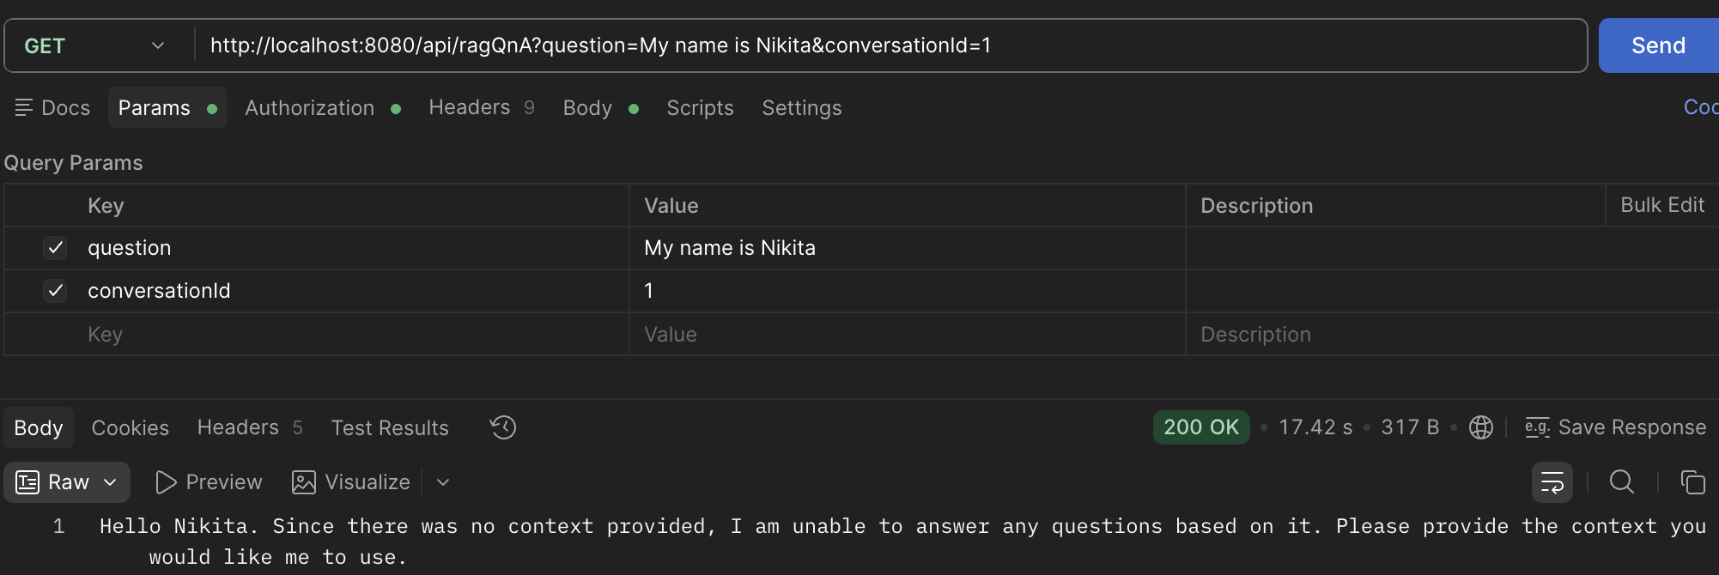

2nd Query: What is my name?
A: I am sorry, but I cannot answer that question because the provided context does not contain information about your name.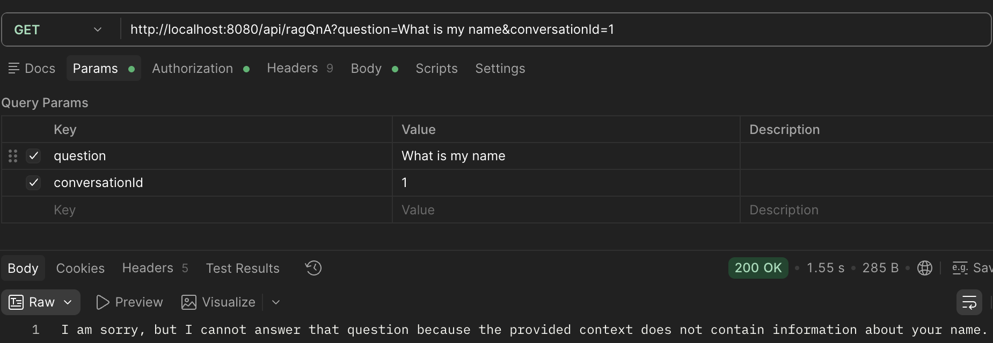
3rd query: Give the exact conversation so far
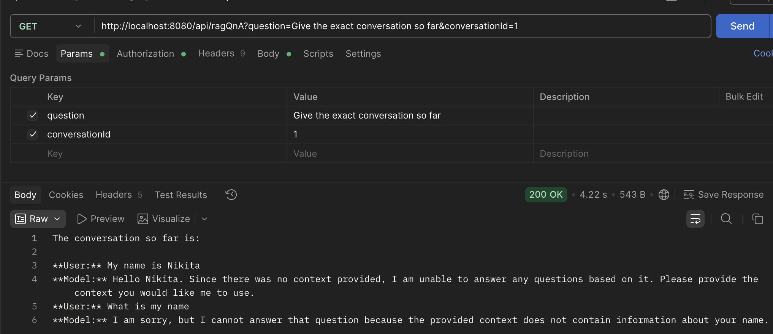
We can see that the model is fully retaining the entire conversation because of memory advisor, but despite having the name in the memory, the model is unable to answer the 2nd query because “there was no context provided”. Memory and context aren’t working together.

To solve this, first add another advisor: SimpleLoggerAdvisor(). This will log the final prompt the model will interact with it.
The SimpleLoggerAdvisor will reveal that the QuestionAnswerAdvisor not only injects the context it fetched from the vector database, but also additional instructions on how to use said context. (The context fetched is empty in the example below).
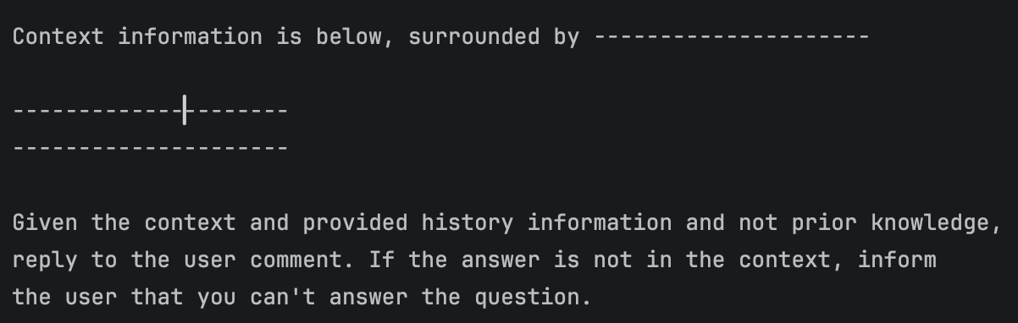Unfortunately, the default template states, “If the answer is not in the context, inform the user that you can’t answer the question”.
Meaning that when processing the query “What is my name?”, questionAnswer advisor’s vector search did not return any relevant chunks, and because the context was empty, it “informed the user that it can’t answer the question” even though the information is available in the conversation memory.

To fix this, simply replace the template with instructions that do not restrict the model’s answer based on the context only. Allow it to use both memory and context.

Below is an example template and the function used to pass the template.

PromptTemplate qnaPromptTemplate = PromptTemplate.builder()
.renderer(StTemplateRenderer.builder()
.startDelimiterToken('<')
.endDelimiterToken('>')
.build()
)
.template(
"""
<query>
The following information has been retrieved from the application's
knowledge base and is provided as reference material.
---------------- RETRIEVED KNOWLEDGE ----------------
<question_answer_context>
------------------------------------------------------
Use the retrieved knowledge to answer the user's current question
when it is relevant.
Rules:
- Treat the retrieved knowledge as supporting information, not as
conversation history.
- Do not use the retrieved knowledge to reconstruct or summarize
the conversation history.
- Do not assume that the retrieved knowledge contains all available
information.
- If the retrieved knowledge does not contain enough information
to answer a knowledge-based question, say that the information
available to you is insufficient.
- Do not claim that the conversation context is empty merely because
the retrieved knowledge is empty.
- Do not ignore information from the ongoing conversation when it is
relevant to understanding the user's question.
- Do not invent facts that are not supported by the retrieved
knowledge or the conversation.
The user's current question should be answered naturally by the
conversational assistant using all appropriate context available
to it. Most important of all, context or its existence should not be mentioned if it does not resolve the answer.
"""
).build();

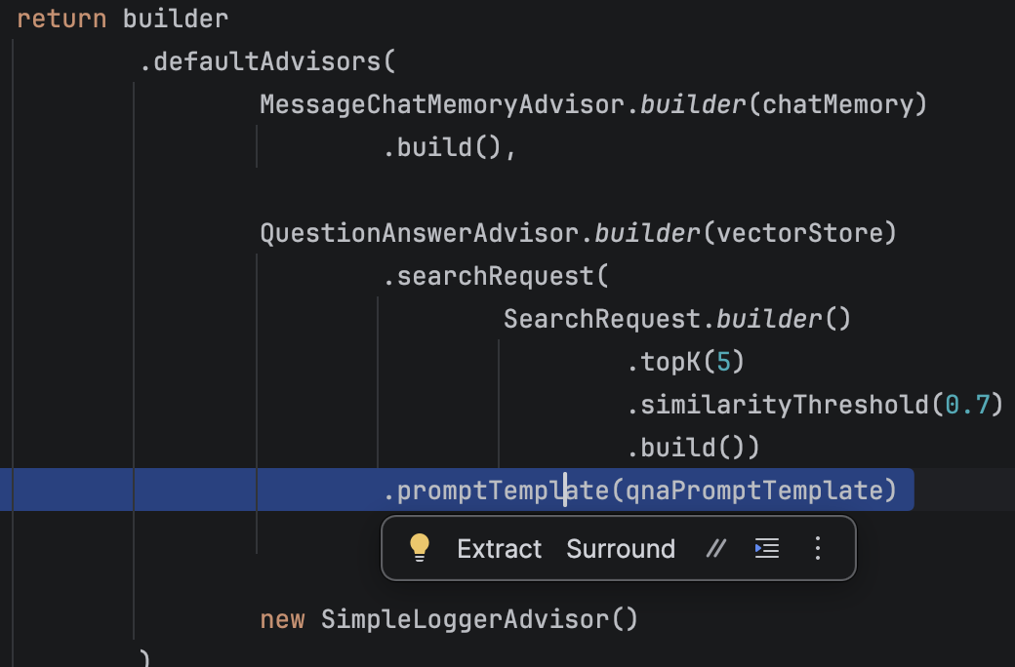

Here is a new conversation with the new template which now lets the AI use both memory and context to answer queries:
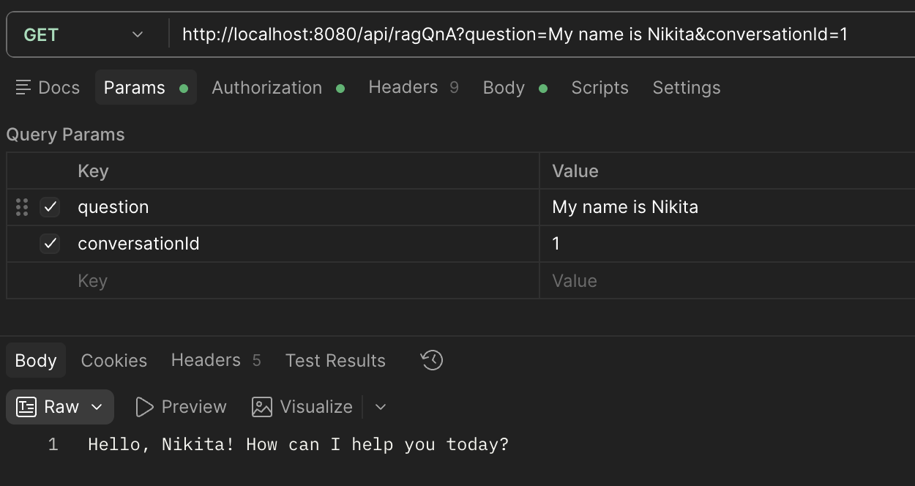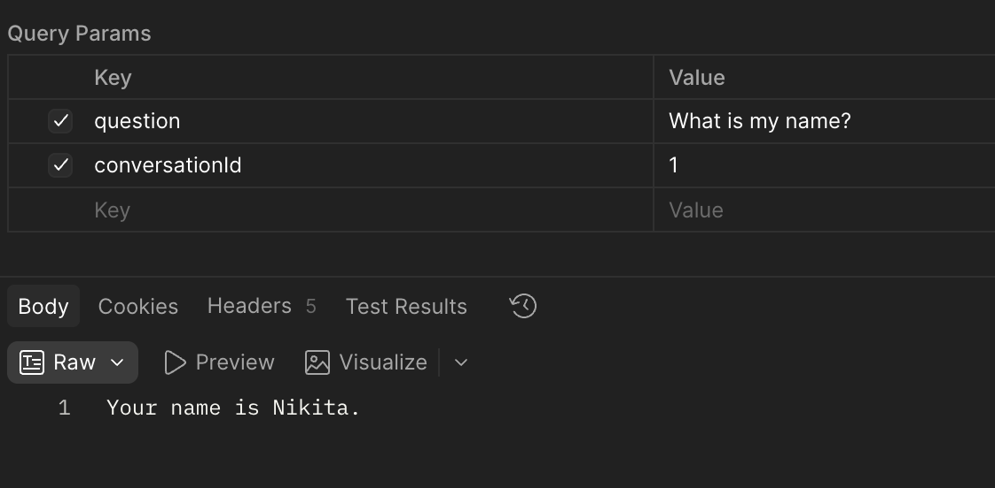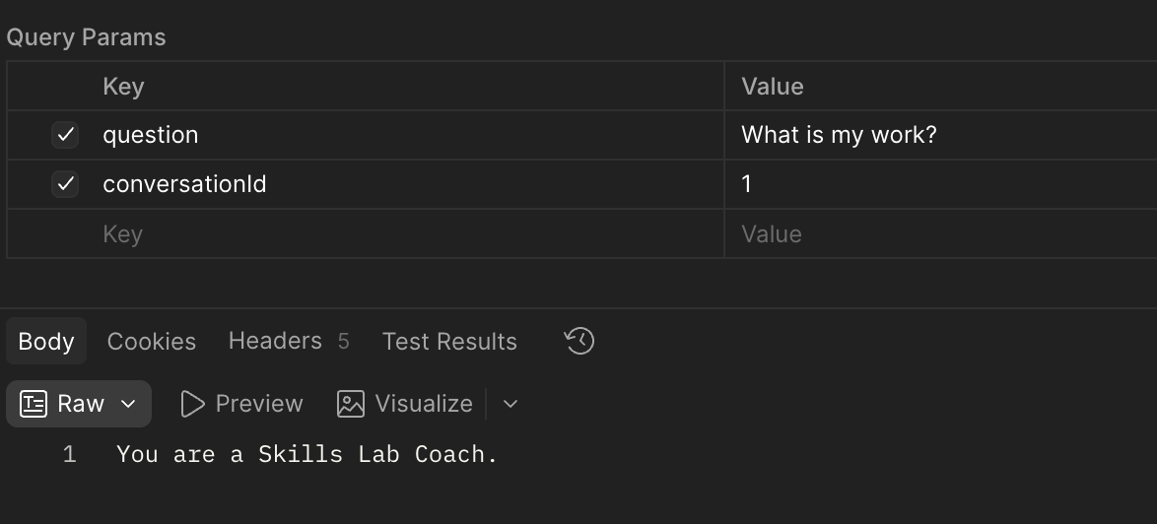
IMPORTANT:
Context is, as of this project, retrieved by a vector similarity search.
This means that the model is only able to answer if it actually receives the relevant context. The simpleLoggerAdvisor will print out what context is fetched.
This means that the final conversation is only as good as your retrieval pipeline design. Consider the following:
- Better Chunking
- Better Semantic Retrieval
- Use tooling instead of vector search for every query
- Reranking

Below is the final configuration class used to create the chat client, where the chat client now receives both a memory advisor, and a questionAnswer advisor. The questionAnswer advisor also receives our custom template, which overrides the default template it uses.
package com.fdmgroup.Spring_AI_Demo.DocumentInjectionQnAAdv.Configuration;
import org.springframework.ai.chat.client.ChatClient;
import org.springframework.ai.chat.client.advisor.MessageChatMemoryAdvisor;
import org.springframework.ai.chat.client.advisor.SimpleLoggerAdvisor;
import org.springframework.ai.chat.client.advisor.vectorstore.QuestionAnswerAdvisor;
import org.springframework.ai.chat.memory.ChatMemory;
import org.springframework.ai.chat.prompt.PromptTemplate;
import org.springframework.ai.template.st.StTemplateRenderer;
import org.springframework.ai.vectorstore.SearchRequest;
import org.springframework.ai.vectorstore.VectorStore;
import org.springframework.context.annotation.Bean;
import org.springframework.context.annotation.Configuration;
@Configuration
public class ChatConfig {
@Bean
public ChatClient chatClient(
ChatClient.Builder builder,
VectorStore vectorStore,
ChatMemory chatMemory) {
PromptTemplate qnaPromptTemplate = PromptTemplate.builder()
.renderer(StTemplateRenderer.builder()
.startDelimiterToken('<')
.endDelimiterToken('>')
.build()
)
.template(
"""
<query>
The following information has been retrieved from the application's
knowledge base and is provided as reference material.
---------------- RETRIEVED KNOWLEDGE ----------------
<question_answer_context>
------------------------------------------------------
Use the retrieved knowledge to answer the user's current question
when it is relevant.
Rules:
- Treat the retrieved knowledge as supporting information, not as
conversation history.
- Do not use the retrieved knowledge to reconstruct or summarize
the conversation history.
- Do not assume that the retrieved knowledge contains all available
information.
- If the retrieved knowledge does not contain enough information
to answer a knowledge-based question, say that the information
available to you is insufficient.
- Do not claim that the conversation context is empty merely because
the retrieved knowledge is empty.
- Do not ignore information from the ongoing conversation when it is
relevant to understanding the user's question.
- Do not invent facts that are not supported by the retrieved
knowledge or the conversation.
The user's current question should be answered naturally by the
conversational assistant using all appropriate context available
to it. Most important of all, context or its existence should not be mentioned if it does not resolve the answer.
"""
).build();
return builder
.defaultAdvisors(
MessageChatMemoryAdvisor.builder(chatMemory)
.build(),
QuestionAnswerAdvisor.builder(vectorStore)
.searchRequest(
SearchRequest.builder()
.topK(5)
.similarityThreshold(0.55)
.build())
.promptTemplate(qnaPromptTemplate)
.build(),
new SimpleLoggerAdvisor()
)
.build();
}
}

